Staplehurst Summer Play Scheme 2024- Activity Timetable

 | Monday 29TH July | Tuesday 30th July | Wednesday 31st July | Thursday 1st August | Friday 2nd August
9-10 |  | Hat designs | Healthy eating fruit and vegetable kebabs. | Big cut outs – paint yourself | Archery Challenge
10.15- 10.30 |  | Handwashing /snack | Handwashing /snack | Handwashing /snack | Handwashing /snack
10.30 -12 |  | Hat designs | Healthy eating fruit and vegetable kebabs. | Big cut outs- paint yourself | Archery Challenge
 | Welcome, meet the team and registration 11-12 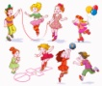 |  |  | 

 | Monday 5th August | Tuesday 6th August | Wednesday 7th August | Thursday 8th August | Friday 9th August
9-10.15 | Big craft/paint. Bubble painting/splat painting /free style  Badges | Clay  creations/impressions | Dance session | Sports day  Sports choice on the field  Football. archery, swing ball. Safe darts, boules skittles, hula hooping, skipping | Water and bubbles Day.Bring in your water shooters/ squeezy bottles please label/  Spare clothes and towel needed
10.15-10.30 | Handwashing  Snack /drink | Handwashing  Snack/drink | Handwashing  Snack/drink | Handwashing  Snack/drink | Handwashing  Snack/drink
10.30-12.00 | Big craft/paint. Bubble painting/splat painting /free style Badges | Archery, swing ball. Safe darts, boules skittles, hula hooping, skipping | Dance session | Archery, swing ball. Safe darts, boules skittles, hula hooping, skipping | Water /bubble fun
12-12.30 | Handwashing  Lunch | Handwashing  Lunch | Handwashing  Lunch | Handwashing  Lunch | Handwashing  Lunch
12.30-2 | Big craft/paint. Bubble painting/splat painting /free style Badges | Clay -paint your creations | Animal afternoon | Sports races -Obstacle course -Running /egg and spoon/wheel barrow/ 3 legged | Water /bubble fun
2-2.15 | Handwashing  Drinks/snack | Handwashing  Drinks/snack | Handwashing  Drinks/snack | Handwashing  Drinks/snack | Handwashing  Drinks/snack
2.15-3 |  | Balloon fun and music | Animal afternoon | Medals and certificates ceremony | Parachute and balloon time
 | 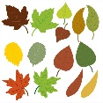 |   This Photo by Unknown Author is licensed under CC BY-SA | 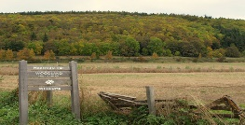  This Photo by Unknown Author is licensed under CC BY |  | 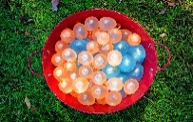

 | Monday 12th August | Tuesday 13th August | Wednesday 14th August | Thursday 15th August | Friday 16th August
9-10.15 | Pizza kitchen | Nerf arena  Wear your superhero / fancy dress outfits | Trip out to:  Wimpy fields Bio Blitz | Inflatable fun  Castles and slide | Party Fun Day  Dress up and enjoy the day
10.15-10.30 | Handwashing  Drinks/snack | Handwashing  Drinks/snack | Handwashing  Drinks/snack | Handwashing  Drinks/snack | Handwashing  Drinks/snack
10.30-12.00 | Pizza Kitchen | Nerf arena and targets | Wimpy fields Bio Blitz | Inflatable fun  Castles and slides | Pinata Balloons  Party games
12-12.30 | Handwashing  lunch | Handwashing  lunch | Handwashing  lunch | Handwashing  lunch | Handwashing  lunch
12.30-2 | Pizza Kitchen | Nerf arena and targets | Wimpy fields Bio Blitz | Inflatable fun  Castle and slides | Entertainer
2-2.15 | Handwashing  Drinks/snack | Handwashing  Drinks/snack | Handwashing  Drinks/snack | Handwashing  Drinks/snack | Handwashing  Drinks/snack
2.15-3 | Group games- musical statues/chairs/football | Parachute and music | Wood flower designs | Limbo challenge | Party games
 |  |  | 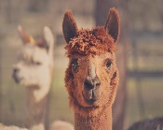 | 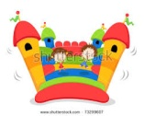

Core activities are available throughout each session.
The core activities may include:
Sports, board games, garden games, arts and crafts, outdoor play, Xbox/Wii console, construction, book corner, quiet area, role play
Please bring in a labelled water bottle

